Lab: Editable List Views

In the previous lab, you created the InteractionsLV and modified the ABContactInteractionsPage PCF file. In this lab, you make modifications so that you can edit interactions for contact and add or remove new rows from the list view.

Requirements

This lab requires that you use TrainingApp 8.0, Guidewire Studio 8.0, and Chrome as your web browser. To view, edit, and delete various contacts, log in to TrainingApp as Alice Applegate. The default URL for TrainingApp is <http://localhost:8880/ab/ContactManager.do>. The login/password for Alice Applegate is aapplegate/gw.

1. Configure an editable List View Panel

In this exercise, you will modify the InteractionsLV in order to allow user to add new interaction details and edit existing details.

Tasks

1. Open Guidewire Studio for TrainingApp
2. From Studio, if your server is not already running, start the server using Debug 'Server'.
3. Review the Debug console for errors and verify that the application is running in the Debug console.
4. Modify TrainingApp so that users can add and remove interactions on the Interactions page
5. Has a toolbar with Edit/Update/Cancel buttons and with Add/Remove buttons
6. Users can add and remove rows upon selecting the appropriate buttons
7. Data in all three columns is editable
8. Shows the checkboxes by each row only when in edit mode

Note: Guidewire Applications render an input widget that references a foreign key field to the User entity differently when in edit mode. When the widget is editable, there is additional User search functionality. This is an aspect of the foreign key to the User entity and not the cell widget itself. In almost all other cases, cell widgets have no special search functionality.

Verification

1. Log in to TrainingApp
2. Log in as Alice Applegate.
3. Reload the PCF changes
4. In TrainingApp, reload the PCF file changes.
5. Edit the Interactions page for William Andy
6. Open the William Andy contact.
7. In the sidebar menu, click Interactions, and then Edit.
8. Add at least three interactions with various dates, interaction reasons, and users.
9. Click Update.

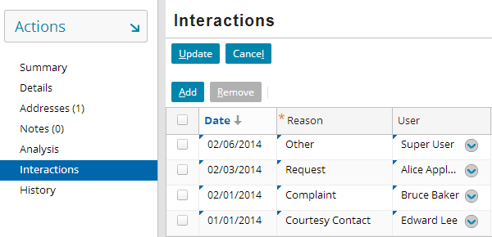

|  |  |
| --- | --- |
|  | Stop and ask your instructor to review your completed lab. |